Rocks and Minerals
Mentor Invitational
February 11th, 2017
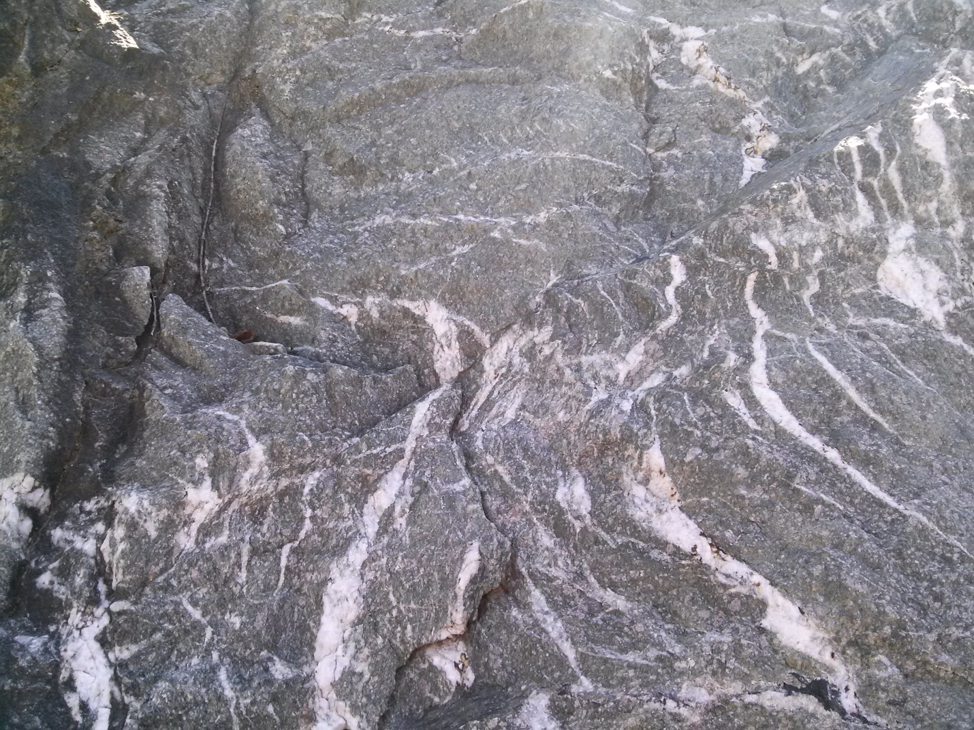
Name(s) _______________________________
School and Team # _______________________
Score _______/70

Station #1
1) Identify this mineral.
______________________________
2. What is the crystal system this mineral belongs to?
a. Orthorhombic
b. Monoclinic
c. Triclinic
d. Hexagonal
3. To what mineral class does this mineral belong to?
a. Sorosilicates
b. Cyclosilicates
c. Nesosilicates
d. Tectosilicates
4. Does this mineral typically display twinning?
Yes No
5. What is the specific gravity of this mineral?
______________________________

Station #2
1. What is the chemical formula of this mineral?
______________________________
2. Which of the following minerals is this mineral NOT commonly associated with?
a. Sphalerite
b. Celestite
c. Calcite
d. Fluorite
3. This mineral is an important ore of what native element?
______________________________
4. This is the State Mineral in which state(s)?
______________________________
5. This mineral has been used as all of the following EXCEPT as ________.
a. mascara
b. as a semiconductor
c. pottery glaze
d. in pencils

Station #3
1. What is the chemical formula of this mineral?
______________________________
2. What type of cleavage does this mineral have?
a. Cubic
b. Basal
c. Rhombohedral
d. Prismatic
3. This mineral is NOT commonly found with what other mineral group?
a. Borates
b. Halides
c. Hydroxides
d. Sulfates
4. Does this mineral typically display fluorescence?
Yes No
5. What is the specific gravity of this mineral?
______________________________

Station #4
1. Identify this mineral.
______________________________
2. Bowen’s Reaction Series illustrates relations between:
a. Temperature, Viscosity, Mineral Composition
b. Temperature, Chemical Composition, Mineral Structure
c. Viscosity, Temperature, Silica Content, Volatile Content
d. Temperature, Viscosity, Pressure
3. To what mineral class does this mineral belong to?
a. Phyllosilicates
b. Nesosilicates
c. Tectosilicates
d. Inosilicates
4. What is the crystal system of this mineral?
a. Tetragonal
b. Orthorhombic
c. Cubic
d. Monoclinic
5. Does this mineral display birefringence?
Yes No

Station #5
1. Identify this mineral.
______________________________
2. Does this mineral display birefringence?
Yes No
3. Does this mineral typically display fluorescence?
Yes No
4. Above what temperature does this mineral display paramagnetism?
a. 6500 K
b. 7000 K
c. 7500 K
d. 8000 K
5. What is this minerals fracture?
______________________________

Station #6
1. What is the chemical formula of this mineral?
______________________________
2. This mineral is the main ore of what element?
______________________________
3. This mineral has the same crystal structure as what other mineral on the Rock and Mineral List?
______________________________
4. This specific specimen displays what optical phenomenon?
______________________________
5. What is the crystal system of this mineral?
a. Hexagonal
b. Tetragonal
c. Triclinic
d. Trigonal

Station #7
1. Identify this mineral.
______________________________
2. What is the crystal habit of this specific specimen?
a. Columnar
b. Tabular
c. Prismatic
d. Reticular
3. This mineral is soluble in what acid?
______________________________
4. What is the crystal system of this mineral?
______________________________
5. What is the specific gravity of this mineral?
a. 2.8
b. 2.85
c. 2.9
d. 2.95

Station #8
1. What is the chemical formula of this mineral?
______________________________
2. To what mineral class does this mineral belong to?
a. Phyllosilicates
b. Nesosilicates
c. Tectosilicates
d. Inosilicates
3. What kind of twinning does this mineral possess most commonly?
a. Carlsbad
b. Manebach
c. Baveno
4. In Ancient Greek, the name of this mineral translates to what?
______________________________
5. This mineral is most commonly found as a constituent in what kinds of rocks?
a. Sedimentary
b. High-grade metamorphic
c. Mafic Igneous
d. Felsic Igneous

Station #9
1. Identify this mineral.
______________________________
2. This is the principal mineral comprising what group of metamorphic rocks?
______________________________
3. The cleavage angles of this mineral are at what degrees?
a. 50 and 130 degrees
b. 53 and 127 degrees
c. 56 and 124 degrees
d. 60 and 120 degrees
4. What mineral on the Rocks and Minerals List does this mineral alter easily into?
______________________________
5. To what mineral class does this mineral belong to?
a. Phyllosilicates
b. Nesosilicates
c. Tectosilicates
d. Inosilicates

Station #10
1. What is the chemical formula of this mineral?
______________________________
2. Which of the following gems are not associated with this mineral?
a. Emerald
b. Ruby
c. Sapphire
d. Padparadsha
3. Abrasive forms of this mineral are synthetically manufactured from what other mineral on the Rocks and Minerals List?
______________________________
4. What is the crystal system of this mineral?
a. Hexagonal
b. Trigonal
c. Triclinic
d. Monoclinic
5. What is the cleavage of this mineral?
______________________________

Station #11
1. Identify this mineral.
______________________________
2. To what mineral class does this mineral belong to?
a. Cyclosilicates
b. Nesosilicates
c. Phyllosilicates
d. Inosilicates
3. What ore bodies are this mineral associated with?
a. Tin and Tungsten
b. Tin and Titanium
c. Titanium and Tungsten
d. Aluminum and Tungsten
4. Instead of glass, this mineral was used in the first _______.
a. Windows
b. Computer screens
c. Bottles
d. Eyeglasses
5. Does this mineral typically display fluorescence?
Yes No

Station #12
1. Identify this mineral.
______________________________
2. Coral preserved in this mineral is often known by what name?
______________________________
3. What is the crystal habit of this specific specimen?
______________________________
4. What is the crystal system of this mineral?
a. Trigonal
b. Rhombohedral
c. Cubic
d. Hexagonal
5. What is this minerals fracture?
______________________________

Station #13
1. Identify this rock.
______________________________
2. Identify the mineral at location A.
______________________________
3. The name of this rock is derived from the Greek word meaning what?
______________________________
4. The mineral at location A is the State Mineral of what state?
______________________________
5. What is the crystal system of the mineral at location A?
a. Triclinic
b. Monoclinic
c. Trigonal
d. Hexagonal

Station #14
1. Identify this mineral.
______________________________
2. What is the crystal system of this mineral?
a. Triclinic
b. Rhombohedral
c. Trigonal
d. Tetragonal
3. What is this minerals hardness?
______________________________
4. Crystallographically, the structure of this mineral is closely related to what other mineral on the Rocks and Minerals List?
______________________________
5. This mineral is soluble in what acid?
______________________________

Station #15
Write in the rock or mineral name that best matches the provided description (1/2 point each)

Rock/Mineral Name | Description
 | Specific gravity of 3.52, cubic shape
 | Hardness of 2, Sulfate group, Monoclinic
 | Golden-yellow streak, specific gravity of 19.3
 | Pale-blue streak, carbonate group
 | Hardness of 3, sulfide group, cubic shape
 | White streak, red-pink color, triclinic
 | Oxide group, red-brown streak, 5.26 specific gravity
 | Composed of at least 25% feldspar, detrital rock
 | Composed of cemented shells averaging 2mm in size or above
 | Forms in hot springs through rapid precipitation

Station #16
Write in the crystal system to the corresponding description (1/2 pt each)
1. No symmetry of any point group.
______________________________
2. Symmetrical across 1 twofold axis of rotation or 1 mirror plane.
______________________________
3. Symmetrical across 3 twofold axes of rotation or 1 twofold axis of rotation and 2 mirror planes.
______________________________
4. Symmetrical across 1 fourfold axis of rotation.
______________________________
5. Symmetrical across 1 threefold axis of rotation.
______________________________
For each ore mineral given, list the element economically extracted from the mineral. (1/2 point each)
Ore Mineral | Element
Bornite
Galena
Beryl
Barite
Sphalerite

