Material Science Answer Packet
Mentor 2017

SCHOOL NAME___________________________________________________TEAM # _____________
Participant’s (1) Name _______________________________________________

Participant’s (2) Name ______________________________________________________

T1: (0 pts) Who is shown in the picture on the front of the test packet?
Sir George Gabriel Stokes
________________________________

#1: (14 pts) T6:
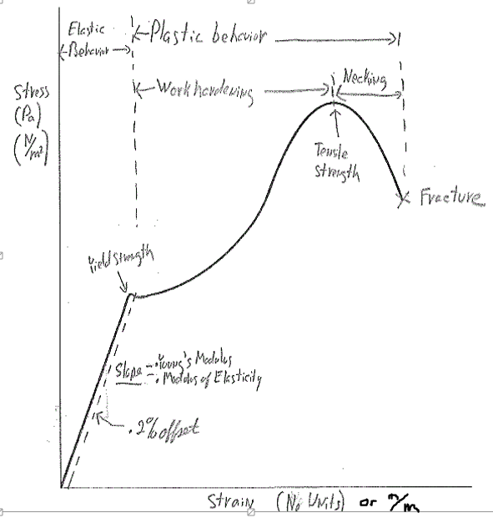
T2: (0 pts) What device is shown on the front of the test packet? Wilhelmy Plate apparatus

__________________________________

#2: (1 pt each)
i. | A | v. | D
ii. | B | vi. | B
iii. | E | vii. | C
iv. | C | viii. | D

#3: (3pts) T5

#4: (1pt) T4 __________________________________________________________

#5: (1pt) __________________________________________________________

#6: (3pts) _____________________________________________________________________
_____________________________________________________________________________
_____________________________________________________________________________
#7: (1 pt each) (T3) Any order:
Ductile | Malleable | Conductor | Has luster (shiny)

#8: (1 pt each)
A. | 30 | B. | 20W-40 | C. | 10W-40
D. | 10W | E. | 5W-30 | F. | 5W-20

Multiple Choice 9-48: (1pt each)
9. | B | 19. | B | 29. | A | 39. | D
10. | C | 20. | A | 30. | B | 40. | D
11. | A | 21. | B | 31. | C | 41. | C
12. | B | 22. | A | 32. | C | 42. | C
13. | C | 23. | D | 33. | D | 43. | C
14. | A | 24. | B | 34. | B | 44. | C
15. | C | 25. | B | 35. | D | 45. | D
16. | B | 26. | B | 36. | B | 46. | C
17. | C | 27. | B | 37. | B | 47. | D
18. | C | 28. | B | 38. | B | 48. | D

49. (2pts) Zero

50. (3pts) (Show Work) 1,700m

51. (3pts) (Show Work) 43,400 N

52. (2pts) The calculation was done assuming the bone was solid.

53. (3pts) (Show work) 374,000 N

#54: (1 pt each)
A. | 101 | B. | 110 | C. | 011
D. | 101 | E. | 1-10 | F. | 01-1
G. | 100 | H. | 010 | I. | 001
J. | -100 | K. | 0-10 | L. | 00-1

55. (1pt)

56. (1pt)

57. (1pt)

58. (2pts) T10

59. (2pts)

60. (2pts)

Multiple Choice 61-92: (1pt each)
61. | D | 69. | E | 77. | C | 85. | C
62. | C | 70. | B | 78. | C | 86. | A
63. | C | 71. | A | 79. | B | 87. | D
64. | A | 72. | D | 80. | A | 88. | B
65. | C | 73. | D | 81. | A | 89. | C
66. | A | 74. | A | 82. | C | 90. | C
67. | C | 75. | B | 83. | E | 91. | C
68. | C | 76. | A | 84. | B | 92. | W

93. (2pts each) T9

a) (200) __________________________ (211) ____________________________

b) (T6)

94. (1 pt each)

O-O ______________ Al-F______________

N-O ______________ H-C ______________ H-O ______________

95. Show work (3 pts) T8

96. (2pts)

97. (1pt each) T7
a)_____________________________________ b)__________________________________

c)_____________________________________ d)__________________________________

Lab #1) Part A- Data Table (10 pts)
Look for sig figs and units. Masses, Forces (using m*g), Area (pi*r^2), L_{o} and delta L.
Stress = F/A and Strain=delta L/L_{o}

Lab #1) Part A- Graph. (5pts)
Graph should have a title, labeled x and y axis with units, plotted data points, and trendline.

Lab #1) Part B- Young’s modulus ___________________________ (5 pts)
(Show Work)

Slope of best fit line.

Lab #1) Part C- Percent error_____________________% (3 pts)

Correct answer based on slope of graph (in units of N/m²) to the accepted value given.

Lab #1) Part D – (2 pts)

Something about plastic vs. elastic or how releasing the masses in a way that may stretch the nylon inconsistently.

Lab #2) Part A - Data Table (10 pts)

Look for sig figs and units. Multiple distances and times. Diameter of BB.

Lab #2) Part B - Graph (5 pts)

Graph should have a title, labeled x and y axis with units, plotted data points, and trendline.

Lab #2) Part B - kinematic viscosity ___________________________________ cSt (8 pts)

Slope of graph is the speed.
Kinematic viscosity = (2/9)*g*r^2*(7.90-1.44)/(1.44*speed)
Answer will be in St and needs to be converted to cSt by multiplying by 100.

Lab #2) Part D – (2 pts)

It assumes a temperature of 100ºC to give the range of kinematic viscosities.

Lab #3A: radius of Al atom ___________________________________ (15 pts)
Something like this:
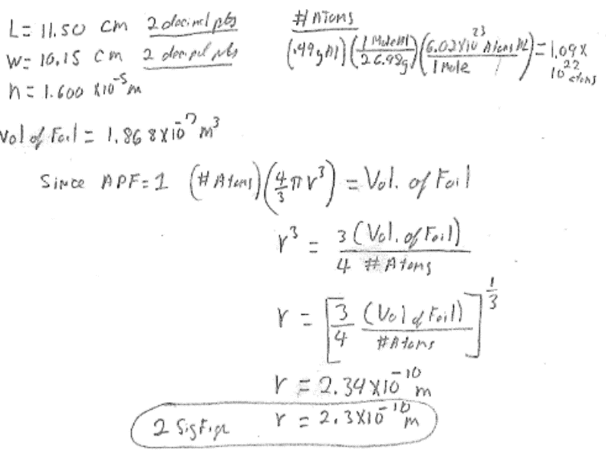

Lab #3B) Part A - (2 pts each)
a_____________________________________ b_______________________________
c__________________________________ d_______________________________
Lab #3B) Part B- rational (3 pts)
The contact angle. The least hydrophilic will have a large contact angle. It becomes more hydrophilic as this angle becomes smaller.

Lab #3B) Part C- two reasons (2 pts each)

Absorption, evaporation, or wicking are acceptable. (2 of these are needed)

