**Material Science**



**Mentor Invitational**

**February 11th, 2017**

**SCHOOL NAME_________________________________________________TEAM NUMBER _______**

Participant’s (1) Name _____________________________________________________

Participant’s (2) Name ______________________________________________________

[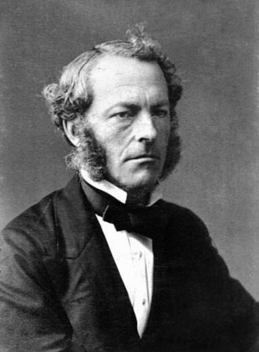](http://upload.wikimedia.org/wikipedia/commons/a/ad/Ggstokes.jpg)

rectifier or full wave bridge rectifier or bridge rectifier.

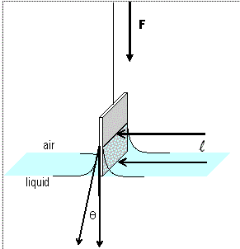



**INSTRUCTIONS**

**1. Turn in all exam materials when directed. Missing exam materials will result in immediate disqualification of the team in question.**

**2. Inappropriate drawings, comments or answers will result in disqualification of the team from this event.**

**3. You may separate the pages but they ALL must be restapled at end of the test.**

**4. Wear your Goggles and Apron/Lab Coat. If you need to remove them for a reason you must turn away from the experiment and face a wall.**

**5. METRIC UNITS and SIGNIFICANT FIGURES! Need I say more?**

**6. Point values for each question are shown.**

**7. You will be rotating through various lab stations. You may work on any part of the test at any time but you may only collect data from a particular lab stations when you are told it is your turn. You are welcome to do any part of the test’s lab questions before or after you have your data. The limitation is only on your time available to collect the data. Use your time wisely.**

**8. When the time is up, *the time is up*. Continuing to write after the time is up risks immediate disqualification.**

**9. The only answers that will be graded are those that you place on the answer sheet. You are free to use this test packet as scratch paper.**

**10. In the event of a tie score, the tie breaking questions are listed as T1-T10.**

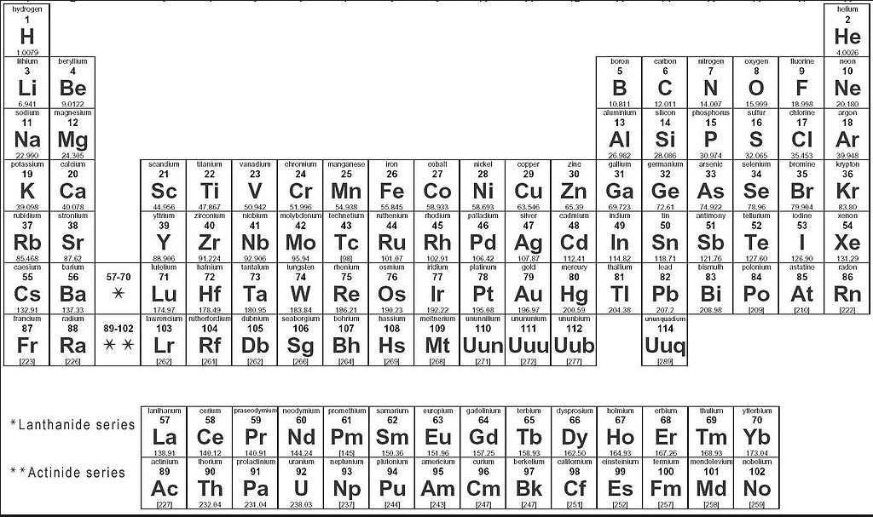

#1: Below is an unlabeled stress-strain curve. Please label or indicate the following: (14 pts total)

Stress axis (with units) (2)

Strain axis (with units) (2)

Young’s modulus (1)

Modulus of elasticity (1)

Plastic behavior (1)

Elastic behavior (1)

Tensile strength (1)

Yield strength (1)

Work hardening (1)

Fracture (1)

Necking region (1)  
Sketch an offset of under 5% (1)

You must be neat, clear and accurate in order to receive full credit. If you are labeling a slope, area, or region, again you must be clear.

#2: Match the term with the appropriate definition (terms may be used more than once).

1. A solid that lacks the long-range order characteristic of a crystal
2. Brittle, hard, strong in compression, weak in shearing and tension
3. Chemical compound(s) consisting of repeating structural units like proteins and polystyrene
4. Generally anisotropic
5. High electrical conductivity, high thermal conductivity, and high density.
6. Inorganic, nonmetallic solid prepared by the action of heat and subsequent cooling
7. Made from two or more constituent materials with significantly different physical or chemical properties
8. Usually inclined to form cations through electron loss, reacting with oxygen in the air to form oxides
9. amorphous
10. ceramics
11. composites
12. metals
13. polymers

#3: Sketch a typical stress-strain curve for a typical crystalline ceramic.

#4: How do non-crystalline ceramics deform? __________

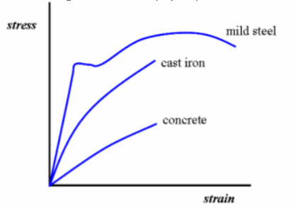#5: Of the three materials on the graph to the right, which is the least tough?

#6: Below is a graph for a copper wire. This curve’s might look to odd to someone Material Science. How would you explain to them that this graph makes sense for copper?

#7: What are the 4 general properties of metals?

#8: In the diagram below there are six segments showing the range at which different motor oils are recommended. Starting from the top of the chart and working your way down identify each of the motor oils as either: 30, 10W, 10W-40, 20W-40, 5W-20, 5W-30.

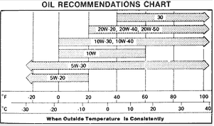

a

A

B

C

D

E

F

9.  Which of the following material has maximum ductility?

A. Mild steel B. Copper C. Nickel D. Aluminum

10. Which of the following when used in ordinary low carbon steels, makes the metal ductile and of good bending qualities?

A. Sulphur B. Phosphorus C. Manganese D. Silicon

11. A eutectoid steel consists of

A. wholly pearlite B. wholly austenite C. pearlite and ferrite D. pearlite and cementite

12. Before compacting the metals, which process is annealed to remove the effects of cold working?

A. Machining B. Crushing C. Shotting D. All of these

13. Cast iron is a

A. ductile material B. malleable material C. brittle material D. tough material

14. A metal has been extensively cold worked and then heated to its recrystallization temperature. The metal’s grain size will:

A. become finer B. become courser C. not change D. Nothing, metals don’t have grains.

15. The hardness is the property of a material due to which it

A. can be drawn into wires B. breaks with little permanent distortion

C. can cut another metal D. can be rolled or hammered into thin sheets

16. What is the relationship between viscosity and flow rate?

1. The greater the viscosity, the faster the flow rate.
2. The greater the viscosity, the slower the flow rate.
3. There is no relationship between viscosity and flow rate.
4. The lower the viscosity, the slower the flow rate.

17. Smelting is the process of

A. removing the impurities like clay, sand etc. from the iron ore by washing with water

B. expelling moisture, CO2, sulfur and arsenic from the iron ore by heating in shallow kilns

C. reducing the ore with carbon in the presence of a flux

D. all of the above

18.  A material is said to be allotropic, if it has

A. fixed structure at all temperatures B. atoms distributed in random pattern

C. different crystal structures at different temperatures D. any one of the above

19. Brass is an alloy of

A. copper and tin B. copper and zinc C. none of these D. copper, tin and zinc

20.  The hardness and tensile strength in austenitic stainless steel can be increased by

A. hardening and cold working B. normalizing C. martempering D. full annealing

21.  The property of a material essential for spring materials is

A. stiffness B. ductility C. resilience D. plasticity

22.  The hardness of steel depends upon the

A. amount of cementite it contains B. amount of carbon it contains

C. contents of alloying elements D. method of manufacture of steel

23. Which of the following statements are true for annealing of steels?

A. Steels are heated to 500 to 700° C B. Cooling is done slowly and steadily

C. Internal stresses are relieved D. all of these

24. 18-4-1 high speed steel contains

A. vanadium 4%, chromium 18% and tungsten 1%

B. vanadium 1%, chromium 4% and tungsten 18%

C. vanadium 18%, chromium 1% and tungsten 4%

D. none of the above

25. The ability for a material to absorb energy in the plastic range is called

A. Creep B. Resilience C. Fatigue Strength D. Toughness

26. Which of the following gives the correct order of increasing hot hardness of cutting tool materials?

A. Diamond, Carbide, High speed steel B. High speed steel, Carbide, Diamond

C. Carbide, Diamond, High speed steel D. High speed steel, Diamond, Carbide

27.  Induction hardening is basically a

A. carburizing process B. surface hardening process

C. core-hardening process D. none of these

28.  The strength is the ability of a material to resist

A. deformation under stress B. externally applied forces with breakdown or yielding

C. fracture due to high impact loads D. none of these

29. The property of a material due to which it breaks with little permanent distortion, is called

A. brittleness B. ductility C. malleability D. plasticity

30. Which of the following statements explains why oil has a greater viscosity than water?

A. Oil molecules are less dense than water molecules.

B. Oil molecules have a more complicated shape than water molecules.

C. Oil molecules have more space in between them than water molecules.

D. Oil molecules always move slower than water molecules.

31. Specify the sequence correctly

A. Grain growth, stress relief, recrystallization B. Grain growth, recrystallization, stress relief

C. Stress relief, recrystallization, grain growth D. Stress relief, grain growth, recrystallization

32.  Which of the following material has nearly zero coefficient of expansion?

A. Stainless steel B. High speed steel C. Invar D. Heat resisting steel

33. Which of the following is an amorphous material?

A. Mica B. Silver C. Lead D. Glass

34. The toughness of a material __________ when it is heated.

A. Remain same B. Decreases C. Increases D. None of these

35.  The machinability of steel is improved by adding

A. nickel B. chromium C. nickel and chromium D. sulfur, lead and phosphorus

36.  The type of space lattice found in alpha-iron is

A. face centered cubic space lattice B. body centered cubic space lattice

C. close packed hexagonal space lattice D. none of these

37.  When a low carbon steel is heated up to upper critical temperature

A. there is no change in grain size B. the average grain size is a minimum

C. the grain size increases very rapidly D. the grain size first increases and then decreases very rapidly

38.  Pearlite consists of

A. 13% carbon and 87% ferrite B. 13% cementite and 87% ferrite

C. 13% ferrite and 87% cementite D. 6.67% carbon and 93.33% iron

39. When the steel is normalized, its

A. yield point increases B. ductility decreases

C. ultimate tensile strength increases D. all of these

40. The alloying element which increases residual magnetism and coercive magnetic force in steel for magnets is

A. chromium B. nickel C. vanadium D. cobalt

41. Which of the following is **not** a factor that affects viscosity?

1. The shape and size of particles. B. The amount of attraction between particles.
2. The container the particles are held in. D. The kinetic energy of the particles.

42.  Quenching is not necessary when hardening is done by

A. case hardening B. flame hardening C. nitriding D. any one of these

43. The ability of a material to resist fracture due to high impact loads, is called

A. strength B. stiffness C. toughness D. brittleness

44. An alloy of copper, tin and zinc is known as

A. brass B. bronze C. gun metal D. muntz metal

45.  The purpose of heat treatment is to

A. relieve the stresses set up in the material after hot or cold working

B. modify the structure of the material

C. change grain size

D. any one of these

46.  Silicon when added to copper improves

A. machinability B. hardness C. hardness and strength D. strength and ductility

47. Which of the following statements regarding the viscosity of fluids is true?

1. Heating gases and liquids will increase their viscosity.
2. Heating gases and liquids will decrease their viscosity.
3. Heating a gas decreases its viscosity; heating a liquid increases its viscosity.
4. Heating a gas increases its viscosity; heating a liquid decreases its viscosity.

48.  The heat treatment process used for softening hardened steel is

A. carburizing B. normalizing C. annealing D. tempering

49. A load of 140. kg is supported by a wire of length 2.55 m and cross sectional area of 0.102cm2. The wire is stretched by 0.192 cm. What is the compressive stress on the wire?

50. You have 2.3m3 of concrete which weighs 22000N. What is the height of the tallest cylindrical pillar, made from this amount of concrete, which will not collapse under its own weight? The compression strength of concrete is 1.6*107 N/m2. (Show work)

51. Assume that bone will fracture if a stress more than 1.01 × 108 N/m2 is exerted. What is the maximum force that can be exerted on the femur bone in the leg of a human if it has a minimum diameter of 2.34 cm? Young’s modulus for bone is 1.72 × 1010 N/m2. (Show work)

52. In reality, under ideal conditions, far less force is required to break a healthy human femur. Why?

53. When the outside temperature is 13.0oC, a steel beam of cross-sectional area 100.cm2 is installed in a building with the ends of the beam bolted securely to two immovable pillars. In the summer the temperature of the beam rises to 30.0oC. What is the compression force on the beam? Assume the coefficient of linear expansion of steel to be 1.10*10-5 (oC)-1 and Young’s modulus of steel is 2.00*1011 N/m2. (Show work)

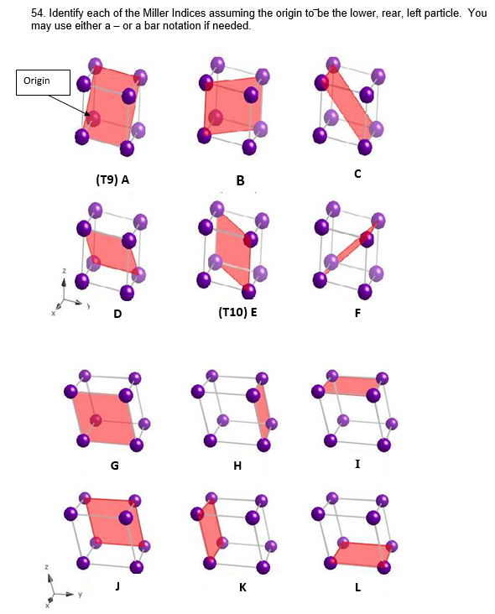

55. X-Ray diffraction is used to determine and measure crystal structure. What does it measure of a unit cell? (1pt)

56. What is the APF for a FCC metal? (1pt)

57. What is the Coordination Number of a FCC metal? (1pt)

**Copper unit cell is FCC. The atomic radius 0.1278nm.**

58. What is the cube edge length of copper’s unit cell in meters?

59. What is the planer density of an outside face of copper’s unit cell in atoms/m2

60. What is the linear density of diagonal of an outside edge of copper’s unit cell in atoms/m?

61. A pure substance melts at 113 °C and does not conduct electricity in either the solid or liquid state. The bonding in this substance is primarily

    A. ionic.     B. network.       C. metallic. D. covalent.

62. Which of these is a characteristic of a highly ionic salt?

A. melts at a low temperature B. has a non–crystalline structure

    C. conducts electricity when melted D. forms long chain–like molecules

E. is a liquid or gas at room temperature

63. What types of bonding exist in sodium hydrogen sulfate, NaHSO4?

    A. ionic only    B. covalent only

C. both ionic and covalent D. both covalent and metallic

64. Very electronegative atoms like Cl are most likely to

A. attract an extra electron B. give up a valence electron

C. form metallic bonds D. none of the above

65. In the solid state, which type of bonding between particles best allows for the conduction of electricity?

    A. ionic               B. covalent               C. metallic D. covalent network

Refer to the drop of water below for next three questions.

66. Measure the contact angle of the drop.

* 1. 90o B. 45o C. 30o D. 120o E. 60 o

67. What type of surface is this drop located on?

* 1. Hydrophilic B. Hydrophobic C. Intermediate

D. Superhydrophobic E. Perfectly wetted

68. Which of the following surfaces could this possibly be?

A. Fused quartz B. Paraffin C. Silver D. Lead glass E. Teflon

69. Which bond has the ***least*** ionic character?

    A. P—Cl    B. H—Cl    C. Br—Cl D. S—Cl E. Cl—Cl

70. The material in which the atoms are arranged regularly in some directions but not in

others, is called

A. amorphous material B. mesomorphous material

C. crystalline material D. none of these

71. The Deacon process has been used to manufacture chlorine at a temperature of 450 °C. The equations for the reaction are:

O2 + 4HCl + 4CuCl 🡪 2H2O + 4CuCl2

4CuCl2 🡪 4CuCl + 2Cl2

    What is the catalyst?

    A. CuCl     B. HCl        C. Cl2         D. H2O

72. Which two elements form a compound having the greatest ionic character?

    A. cesium and fluorine   B. potassium and oxygen

    C. lithium and sulfur D. francium and fluorine

73. Crystal structure of a material is, generally, examined by

A. naked eye B. optical microscope C. metallurgical microscope D. X-ray techniques

74. The malleability, conductivity, ductility, and luster of metals can be explained by

    A. mobile electrons.    B.  localized electrons.

    C. equally shared electron pairs. D. unequally shared electron pairs.

75. Which description applies to compound **XY** if elements **X** and **Y** have a large difference in electronegativity?

    A. Its atoms repel each other.    B.  The bond is primarily ionic.

    C.  The bond is primarily metallic. D. The bond is coordinate covalent.

76. A solid has no electrical conductivity at room temperature. It is heated to 600 °C, melts, and then has electrical conductivity. The solid has which type of bonding?

    A. ionic bonding   B. covalent bonding

C. metallic bonding D. van der Waals forces

77. Body centered cubic space lattice is found in

A. Zinc, magnesium, cobalt, cadmium, antimony and bismuth

B. Gamma iron, aluminum, copper, lead, silver and nickel

C. Alpha iron, tungsten, chromium and molybdenum

D. None of the above

78. The bond between the two carbon atoms in ethene, C2H4, is essentially

    A. polar covalent.       B. single covalent. C. double covalent. D. triple covalent.

79. The electronic configuration for carbon is 1*s*22*s*22*px*12*py*12*pz*0. Which concept explains the formation of four single covalent bonds in compounds such as methane, CH4?

    A. pi bonding B. hybridization C. hydrogen bonding

    D. bond overlapping E. coordinate covalent bonding

80. The type of space lattice found in gamma-iron is

A. face centred cubic space lattice B.body centred cubic space lattice

C. close packed hexagonal space lattice D. none of these

81. Which of these compounds exhibits the greatest covalent character?

    A. NO        B. MgO    C.  CsF        D.  NaCl E.  Rb2S

82. A reliable indicator of a nation's industrial productivity is its total consumption of

    A. sodium nitrate.              B.potassium carbonate.

C. sulfuric acid. D. citric acid. E. potassium chlorate

83. In molecular crystals such as those of Ne and N2, which type of bonding exists between the molecules?

    A. ionic         B.  covalent            C. metallic D. hydrogen E. van der Waals

84. There are fourteen atoms in a unit cell of

A. Body centered cubic space lattice B. Face centered cubic space lattice

C. Close packed hexagonal space lattice D. None of these

85. Classify solid carbon (diamond) according to its structure.

    A. ionic solid    B. metallic solid  C. covalent network solid D. covalent molecular solid

86. The bond formed by transferring electrons from one atom to another is called

(A) Ionic bond (B) Covalent bond (C) Metallic bond (D) None of these

87. The large scale metallurgical process for obtaining iron from its most common ore is the

    A. Bessemer Process. B. electrolysis of iron oxide. C. roasting of iron sulfide ores.

    D. reduction of iron oxide by carbon. E. flotation of iron bearing concentrates.

88. Which substance has bonds of greatest ionic character?

    A. gaseous hydrogen, H2 B.  lithium fluoride, LiF

C. xenon tetrafluoride, XeF4 D. gaseous fluorine, F2

89. The metallurgical process that is primarily a physical rather than chemical action is

    A. formation of a slag in a blast furnace. B. roasting a sulfide ore.

    C. concentrating a sulfide ore by froth–flotation. D. electrolysis of a melted salt.

E. recovering iron from iron ore.

90. Which is most effective in changing a gas into a liquid?

    A. Reduce the temperature and pressure.

    B. Increase the temperature and pressure.

    C. Reduce the temperature and increase the pressure.

    D. Increase the temperature and reduce the pressure.

E. Increase the temperature but hold pressure constant.

91. A chemical bond is considered to be predominantly ionic if

    A. atoms of the same element combine.

    B. the reaction forming the bond is endothermic.

    C. atoms of an active metal combine with the atoms of an active nonmetal.

    D. the bond is between atoms of elements which are of the same family.

E. atoms of one metal combine with atoms of another metal.

92. Let’s see who is just guessing at this point. The answer to this question is just the letter “W”.

93. The below figure shows an x-ray diffraction pattern using monochromatic x-radiation having a wavelength of 0.1452nm; each diffraction peak on the pattern has been indexed.

a) Calculate the Interplanar spacing for (200) and (211) planes.

b) (T6) Calculate the lattice parameter of (200) assuming it is a cubic crystal.

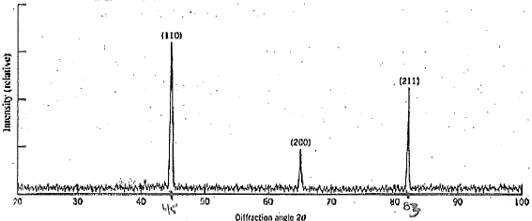

What do the following stand for?

i. CCP ii. HCP iii. BCC iv. FCC

94. On the answer sheet you will find a list of binary compounds. Are the bonds Ionic, Covalent, Polar covalent?

95. What is percentage ionic character for C-F bond (electronegativity for C is 2.5; for F is 4.0)?

96. In ceramics, many of the bonds are ionic. For a coordination number of 3 (anion), what is the range of cation/anion radius ratio for a stable ceramic structure.

97. What are each of the following abbreviations short for?

a) CCP b) HCP c) FCC d) BCC

Lab #1: You are given segment(s) of nylon which you are told has a Young’s Modulus is 5.00*109 N/m2. Using the masses, caliper, and meterstick you are given:

a) Collect data (which you will record in a data table) and plot a Stress vs Strain graph.

b) Use this graph to determine your experimental Young’s modulus. If you know how to perform the regression analysis show the first step of this equation (otherwise just draw a best fit line). Assume the thickness of the nylon does not change, that the masses are labeled correctly to the nearest gram, and that the acceleration of gravity is 9.81m/sec2.

c) What is your percent error?

d) Besides the assumptions listed in (b), what would be the major flaw in this experiment in trying to calculate the Young’s modulus of this nylon?

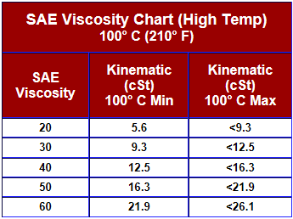Lab #2: You are given a tube filled with motor oil and a steel BB. Using a ruler, stopwatch, and caliper you are given:

a) Collect data (which you will record in a data table) and plot a Distance vs Time graph.

b) (T4) Use this graph to help you determine the kinematic viscosity (in cSt) of this motor oil. Assume the density of the motor oil is 1.44g/mL and the density of steel is 7.90g/mL.

c) (T2) Based on the chart to the right what would be the major flaw in trying to use your answer to (b) to determine the type of motor oil in the tube?

Lab #3 A: Using the large aluminum foil rectangle, balance, and ruler calculate the radius of an aluminum atom. Assume an atomic packing factor of 1.000 and that the thickness of the Al foil is 1.600 * 10-5m. Record all measurements, show your work in a neat and organized manner so that we can following your reasoning.

Lab #3 B: Using the pipette place one to five drops of water on the aluminum foil, the wax paper, the paper, and the glass slide. Based on your observations:

1. Rank these materials from least hydrophilic to most hydrophilic.
2. How did you make the determination for your answers to the question above?
3. Give two reasons why you would want to make your determination as quickly as possible.